Apache Kafka is an open-source platform that allows users to collect, process, and store data streams in real-time:

- Data streams: Kafka can handle data that is continuously generated by many sources, such as thousands of data sources sending records simultaneously.

- Scalability: Kafka can scale to handle billions of events per minute.

- Storage: Kafka can store streams of records in the order they were generated.

- Processing: Kafka can process streams of records in real time.

- Fault tolerance: Kafka is a durable and fault-tolerant messaging system.

- Centralization: Kafka can centralize data from various sources into one place.

- Integration: Kafka can import and export data from other systems using the Kafka Connect framework.
What are the benefits of using Apache Kafka?
- Scalability
Kafka's distributed architecture allows data to be distributed across multiple servers, making it highly scalable.

- Performance
Kafka delivers high throughput for both publishing and subscribing, even when dealing with large amounts of stored messages.

- Durability
Kafka's data is written to disk and replicated across multiple servers, making it fault-tolerant and durable.

- Low latency
Kafka decouples data streams to minimize latency, making it very fast.

- Enterprise security
Kafka provides enterprise-grade security features for authentication and authorization.

- Event-driven architecture
Kafka's event-driven architecture is well-suited for processing large amounts of data.

- Access control
Kafka provides granular control over access to objects and operations within the cluster through the use of ACLs
Kafka Broker
a Kafka cluster consists of several Kafka brokers. A broker is essentially a server, but in Kafka terminology, they’re known as brokers because they handle data (sending and receiving).
It contains topic partitions (log files) that store messages in an immutable sequence. Producers send messages to Kafka brokers, and the broker stores the data across multiple partitions. Consumers connect to these brokers to fetch data from the topics they subscribe to. Kafa brokers ensure that data is reliably available to consumers despite potential system failures.
Core functions of Kafka brokers
Kafka brokers perform core data and metadata management tasks central to Kafka’s operation as a robust, scalable, and fault-tolerant data streaming system.
Message management
When a producer publishes a message to a topic, the broker determines which partition within the topic to place the message based on either the producer's specified key (which determines the partition deterministically) or through a round-robin selection if no key is specified.
Consumers typically operate as a group to read records from the topic partitions. Each consumer in a group reads from exclusive partitions of the topic, and Kafka brokers keep track of which consumer is reading from which partition. This coordination helps effectively distribute the load and ensure that each message is delivered to only one consumer in the group as per the group's consumption policy.
Kafka brokers also track the offsets, which are the positions within the log of each partition, to know which messages have been consumed and which have not. Keeping track of offsets ensures that consumers can resume consuming from where they left off in case of failures or rebalances among consumers in a group.
You can read more about Kafka consumer groups in a different chapter of this guide.
Replication
Multiple brokers get together and operate as a cluster for high availability and scalability. Kafka can replicate each partition across multiple brokers in the cluster. One of the brokers in the cluster acts as the partition leader. The leader for each partition handles all read and write requests for that partition, while follower replicas sync their state to the leader. Upon a leader's failure, one of the followers is automatically elected as the new leader. This means that even if a broker goes down, the data is not lost and can still be served by other brokers with replicas of the same partition.
Metadata management
Brokers also handle significant amounts of metadata, essential for Kafka's functioning. For example, they track the creation of new topics and partitions and manage their respective metadata. This includes maintaining a list of topics, the number of partitions each topic has, and the location of those partitions across the cluster's brokers.

Kafka broker management within a cluster
An external software component called ZooKeeper was traditionally used to manage broker metadata and coordinate broker states within the cluster. However, it created multiple interactions and dependencies that complicated Kafka system management and scalability.
Recently (since version 3.3), Kafka has transitioned to Zookeeper-less Kafka with KRaft. We cover this topic in detail in our chapter on Kafka Zookeeper and only give an overview below.
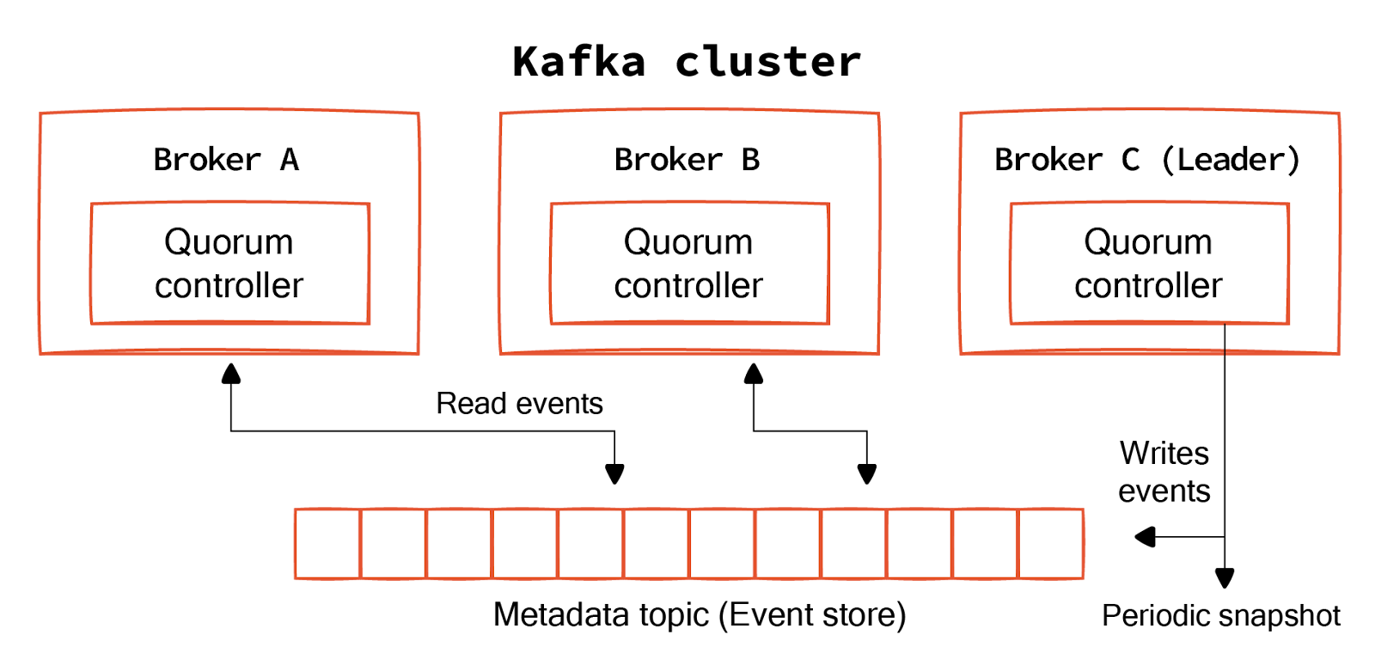
Quorum controller
Brokers in a cluster can act as controllers or voters. Controllers manage the cluster metadata and ensure a consistent state across the cluster through a consensus mechanism. These controllers form a quorum—a subset of the Kafka brokers that actively participate in the consensus process to agree on metadata updates.
Metadata log
All metadata changes within a cluster are recorded as a sequence of events in a special Kafka topic known as the Metadata Topic or Event Store. Kafka replicates this log across the controllers, ensuring durability and fault tolerance. Each event in the log represents a metadata operation, such as creating a new topic or modifying an existing one.
Leader election
The quorum controllers use the Raft consensus algorithm to elect a leader among themselves. The leader is responsible for processing all write requests to the metadata and for replicating these changes to the other controllers (followers). The leadership can change during failures, ensuring the cluster remains operational.
The leader broker (Broker C in the diagram above) is responsible for handling all write operations to the metadata topic. It accepts metadata updates, logs them to the metadata topic, and then propagates these changes to other brokers.
The leader also periodically snapshots the metadata state to optimize performance and ensure the metadata topic doesn’t grow indefinitely. These snapshots allow brokers to quickly recover or bootstrap without needing to replay the entire metadata log from the beginning.
Read events
Brokers can read from the metadata topic to stay updated with the latest cluster configuration and metadata state. This ensures that each broker has access to consistent and up-to-date metadata.
Safety
KRaft ensures safety properties to maintain consistency. At most, one leader can be elected in a given period. This prevents multiple leaders from being elected simultaneously, which could lead to conflicting log entries. If two logs contain entries with the same index and term, they are guaranteed to be identical up to that point. This ensures that all committed log entries are identical across brokers. KRaft also supports cluster membership changes, allowing brokers to join or leave the cluster dynamically without compromising safety or consistency.
Topics.
In other words, Kafka Topics are Virtual Groups or Logs that hold messages and events in a logical order, allowing users to send and receive data between Kafka Servers with ease.
In Kafka, topics work as a commit log. You can think of a topic as a log file that temporarily stores messages as they move from producers to consumers. It contains an ordered sequence of messages. Producers append messages at one end of the log, and consumers read messages from the other. The entire process is explained in detail in our guide on Kafka logs. We give an overview below.
Overview
Producers create messages and write to topics. Kafka’s partition mapper decides the partition to which each message goes. All messages with the same key go to the same partition. Based on configurations, producers can adopt a fire-and-forget approach or wait for an acknowledgment from the Kafka broker to receive messages successfully.
Kafka producers will retry sending messages in case of certain errors. The parameter ‘retries’ controls the number of times the producer attempts to retry the message if it receives an error. The attribute ‘delivery.timeout.ms’ controls the time the producer retries before declaring the message a failure.
Consumers subscribe to one or more topics. Unlike the other pub/sub implementations, Kafka doesn’t push messages to consumers. Instead, consumers have to pull messages off Kafka topic partitions.
A consumer connects to a subscribed topic partition in a broker and reads the messages in the order in which they were written. Kafka supports single and multiple-topic subscriptions so that consumers can read messages from different topics concurrently.
Kafka groups the consumers into consumer groups to aid scaling. All consumers in the group subscribe to the same topic. Kafka's consumer group coordination mechanism ensures the subscribed topic partitions are evenly distributed among consumers. It facilitates dynamic redistribution (or rebalancing) when consumers join or leave the group.
Consumers fetch messages only from the partitions they are assigned to. Each topic partition can be consumed by only one consumer within the group. This ensures sequential message processing and ordering guarantees within a partition.
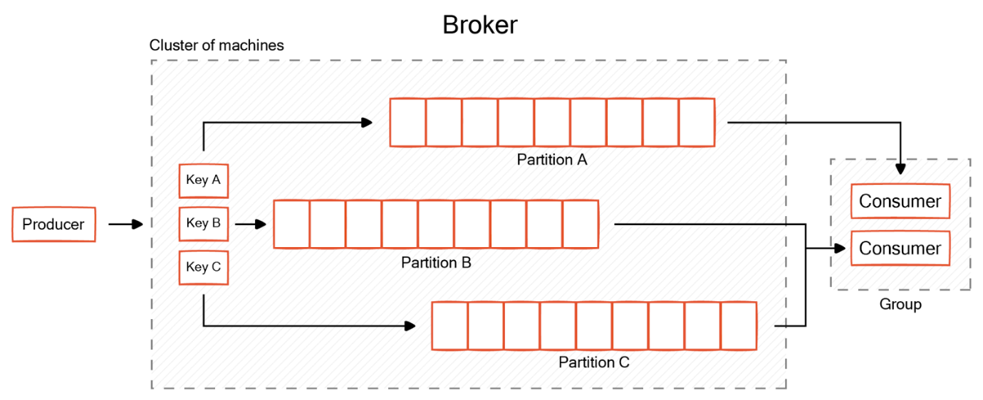
Kafka consumer groups consuming messages from topic partitions
Topic partition offsets
Topic partitions are the fundamental storage element of Kafka. Inside the partitions, Kafka uses offsets to keep track of messages. Offsets represent the order of a message from the beginning of a partition. Offsets help Kafka ensure message ordering and establish delivery guarantees.
Inside the partitions, Kafka divides the data into segments. A segment represents a file in Kafka’s directory structure. Only one segment is active at a time, and Kafka writes the latest data to this segment.
One can control the point at which Kafka commits a segment and begins another segment through two configuration parameters:
- log.segment.bytes controls the maximum size beyond which the segment is committed.
- log.segment.ms controls the maximum time Kafka will keep a segment open.
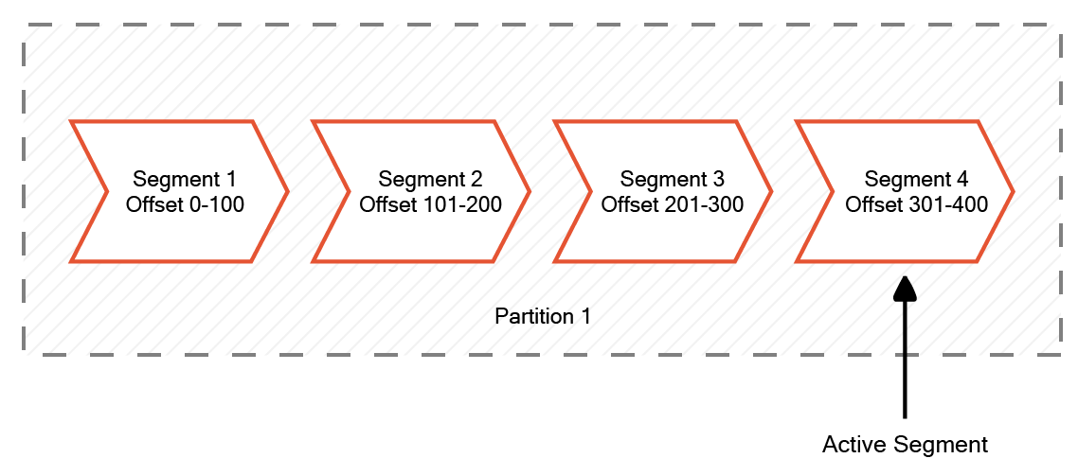
Kafka topic partition offsets
Replication
Kafka partitions are replicated across multiple servers for high message durability. The replication factor is configurable at the topic level. Each topic partition has a leader partition and a set of replicas. All writes will go through the leader partition. Kafka keeps the replica partitions in sync so that any of them can take over when the leader fails.
If the ‘acks’ parameter is set to 0, Kafka adopts the fire-and-forget approach. If it is set to 1, the producer waits for the acknowledgment of the partition leader. The default value for this parameter is ‘all.’
In this case, the producer waits for all the in-sync partition replicas to confirm reception. This increases durability but comes at the cost of some performance. Kafka replication thus allows developers to customize the balance between durability and throughput.
Schema management
Schema management in Kafka involves establishing standards in the data flow from producers to consumers. Since there is no coordination between producers and consumers in Kafka, it is difficult to establish standards regarding data format within the data. This is where schema management helps.
Kafka manages schema through its schema registry component. For use cases where adhering to specific formats is important, you can use a schema registry to enforce a common format.
Data stays as bytes within the topics. Kafka producers use serializers to convert complex business objects to bytes. Similarly, Kafka consumers use deserializers to convert the fetched bytes to original business objects. A schema registry helps store the schema of these business objects and automatically validates them whenever new messages come.
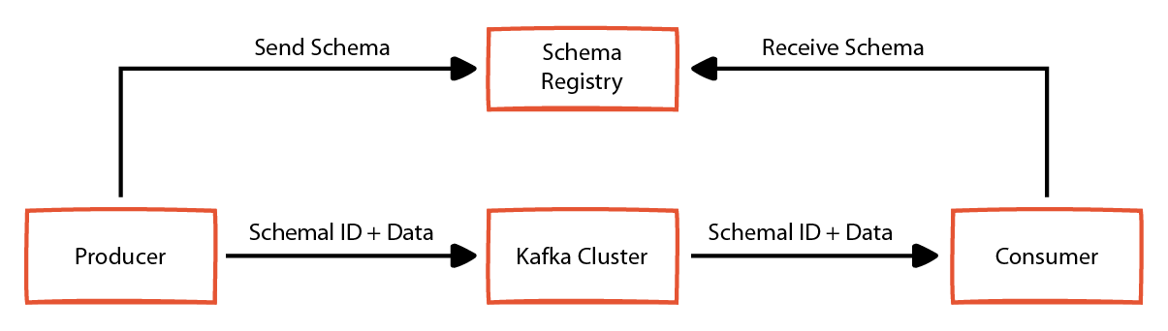
Schema management in Kafka
Compression
Kafka supports compressing data stored in topics to optimize storage. It supports automatically compressing data at the topic level or accepting compressed producer data. One can control the compression behavior using the parameter ‘compression.type’.
In cases where the producer is responsible for compression, this parameter takes the value ‘producer.’ This means compressed data from the producer stays in the same state in topics.
Developers can set it to one of the supported algorithms at the topic level: gzip, snappy, lz4, or zstd. If you configure a different algorithm at the topic level, Kafka recompresses the data using the configured compression algorithm.
Metadata management
Kafka metadata includes information about topics, their partitions, in-sync replicas, and other configurations. Kafka supports two methods for metadata management: an external service called Apache ZooKeeper™ or an internal metadata topic in KRaft configuration mode. It is advisable to use KRaft mode for newer clusters since it is more modern and eliminates many bottlenecks related to Kafka performance.
In KRaft mode, Kafka maintains a metadata log with a quorum of controllers. A leader controller handles all broker requests. The metadata topic is handled like other topics —with partitions, replicas, and offsets.
Setting up and configuring Kafka topics
Kafka provides several utility scripts to set up and manage topics. This section uses two scripts, ‘kafka-topics.sh’ and ‘kafka-configs.sh’, to manage Kafka topics.
To create a new Kafka topic, execute the below command in the CLI.
bin/kafka-topics.sh --bootstrap-server <server_url> --create --topic test-topic --partitions 1 --replication-factor 3
The above command creates a new topic named ‘test-topic’ with a replication factor of 3 and a single partition. One can use the ‘kafka-topics.sh’ to alter any configurations related to an existing Kafka topic.
bin/kafka-configs.sh --bootstrap-server <server_url> --entity-type topics --entity-name test-topic --alter --add-config log.segment.bytes=32000
The above command alters the ‘log.segment.bytes’ parameter for an existing topic named ‘test-topic.’
Best practices in Kafka topics
Kafka provides several configuration parameters to optimize its performance according to use cases. The following section details best practices around some of the topic-level configuration parameters.
Optimize the number of partitions
Number of partitions in a topic is a key factor that affects the performance of your cluster. Since a partition is assigned only one consumer at a time, the number of partitions is always kept at par or higher to prevent idle consumers. Since partitions are the basic element of parallelism in Kafka, you determine their number to finish processing the incoming messages in a reasonable time.
As a best practice, add a small buffer percentage to your required number to cover any bursts. You also need to consider any custom key-based partitioning strategy that is in use.
For example, if you use a partition key that can result in a high data volume in a few partitions, the overall topic gets skewed, and the consumers cannot keep up. Having thousands of partitions is also a bad idea since it increases the overhead in the cluster and reduces performance.
Keep in-sync replication below the replication factor
Kafka replicates the partitions to different servers to guard against failures. Depending upon the configuration, producers can wait until all replicas confirm receipt of messages before moving to the next item. While this improves durability, it can lead to a drop in throughput.
Kafka allows configuring the number of in-sync replicas at the topic level through the configuration parameter ‘min.insync.replicas’. Setting this to a value slightly less than the replication factor is often preferred to balance durability and performance.
Use the same compression algorithm for producers and their topic
The ideal scenario for using compression in Kafka is to use the same compression algorithm in both producer and topic. While Kafka allows configuring separate compression algorithms for topics, this causes additional overhead because messages need to be recompressed. Set the topic ‘compression.type’ parameter to the value ‘producer.’ Kafka automatically uses the same compression algorithm that the producer uses.
Typically ‘lz4’ compression provides the best performance, and ‘gzip’ has a better compression ratio. That said, each use case is unique and may require independent evaluation to arrive at the best method.
Turn off automatic validation if not strictly necessary
If the schema registry is turned on, Kafka can automatically validate the messages' schema and raise errors. This helps establish governance standards but is not necessary in all use cases. Having this option enabled may introduce some overhead and can affect throughput. This effect may be higher in cases where compression is enabled because Kafka needs to decompress messages to validate schema.
But if your use case requires schema evolution, none of these arguments are strong enough to avoid schema validation. In that case, keep automatic validation turned on.
Consumer_Offset

A consumer offset in Apache Kafka is a unique identifier that tracks the position of a consumer in a partition of a topic:

- Purpose
A consumer offset tracks the progress of a consumer group and indicates where a consumer should resume reading from if there is a pause or failure.

- How it works
A consumer offset is an integer that marks the last message a consumer has processed in a partition. Consumers can automatically commit offsets periodically or manually control the committed position.

- Importance
Keeping track of consumer offsets is important for data continuity, especially in financial services.

- Storage
Consumer offsets are stored in the __consumer_offsets internal topic.

- Configuration
The enable.auto.commit setting enables automatic offset committing, and the auto.offset.reset setting defines the consumer's behavior when there is no committed position.

